CHILDREN’S EDUCATIONAL RESPONSIBILITIES
I am proud of the special gifts and talents which God has given me and promise to try to use them wisely.

Therefore I will try to:

- Attend school regularly and on time.

- Wear the school uniform.

- Walk and talk quietly around school and show respect.

- Work hard and always do my best.

- Behave sensibly and be kind to others in our school family.

- Follow class rules and do what is expected by school staff.

Signed ------------------------------------ (Pupil)

PRINT NAME: ___________________________________________

St Anne’s & St Joseph’s RC Primary School

HOME – SCHOOL AGREEMENT

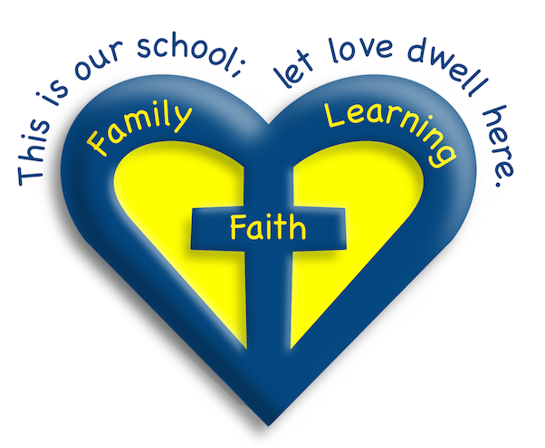

Our School Mission Statement

THIS IS OUR SCHOOL; LET LOVE DWELL HERE
St. Anne’s and St. Joseph’s Catholic Primary School
serves the families of St. Anne’s Parish and St. Joseph’s Parish
bringing them together in one community.
A school family which conducts everyday life
in accordance with God’s teaching
as exemplified by the life and teaching
of Jesus Christ and His Church.
We aim to provide a safe, welcoming, caring
and Christian environment
built on love, tolerance and justice
where everyone can feel happy and secure
and in which God’s presence can be seen
in the way in which all members of the school community
interact with each other.
This will enable the children to develop a
sense of their own worth to respect the worth of others
and to take their place in the community outside school.
Within this framework we strive to offer opportunities
for each child to develop their unique character
to their full potential, spiritually, academically,
morally, socially, and physically.
through the teaching of Catholic doctrine
and the celebration of Catholic Liturgy
we hope to foster in our children a love
of our Catholic heritage
which they will carry into adult life.

SCHOOL’S EDUCATIONAL RESPONSIBILITIES
We acknowledge our responsibility to support parents in their task of nurturing their children within our Christian community.

Therefore we will try to:

- Provide a friendly welcome to your child and a secure, stimulating and happy environment in which to learn.

- Ensure that your child is valued for who he/she is, and is treated with the dignity and respect they deserve.

- Do our best to fulfil our Mission Statement by providing the best possible education we can for your child and enthusiastic teaching rooted in our beliefs, values and skills.

- Provide you with information about your child’s learning and opportunities to talk to teachers about your child’s progress.

- Keep you well informed about school policies and activities through our website, newsletters, consultation papers and parents’ nights.

- Contact you if there is a problem with your child’s attendance and punctuality.

- Inform you of any concerns regarding your child’s progress or health.

- Set, mark and monitor homework suitable to your child’s needs.

Signed ----------Debbie Mulcock----(Acting Headteacher)

PARENTS’ RESPONSIBILITIES
We acknowledge that we as parents are the primary educators of our children and have an irreplaceable role to play in supporting our children’s learning at school.

Therefore I/we will try to:

- See that my child attends school regularly, on time, equipped and suitably rested.

- Encourage my child to be enthusiastic about learning and enjoy school.

- Talk to my child about their experiences in school and encourage them to do their best.

- Inform the school of any concerns or problems that might affect my child’s work or behaviour.

- Support the school’s values, policies and guidelines for behaviour, and encourage my child to show kindness, respect and consideration for others.

- Attend parents’ evenings and discussions about my child’s progress.

- Ensure that my child wears appropriate labelled uniform and follows guidelines relating to PE kits, footwear and jewellery.

- Give my child opportunities for home learning and support homework from school.

Signed --------------------------(Parent/Guardian)
PRINT NAME: _______________________________

