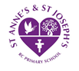 **St Anne’s and St Joseph’s RC Primary School** 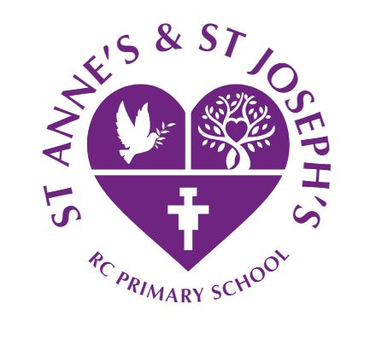

**Supplementary Information Form**

**Admission to Primary School – September 2025**

**SCHOOL APPLIED FOR:**

Name of school:­­­­­­­­­­­­­ ________________________________________________________________________

Address of school: ________________________________________________________________________

**APPLICANT INFORMATION:**

Name of parent(s)/guardian(s): ______________________________________________________________

______________________________________________________________

Address: _______________________________________________________________________________

**CHILD INFORMATION:**

Name of child: __________________________________________________________________________

Address of child: _________________________________________________________________________

(if different from above)

Is the child a baptised Catholic? Yes 🗆 No 🗆

If 'yes', give the parish and date of baptism:

______________________________________________________________________________________

In which parish does the child currently live *(see note 2 – overleaf)*:

______________________________________________________________________________________

If the child is not baptised Catholic please state to which denomination or faith the child belongs *(see note 3 – overleaf)*:

______________________________________________________________________________________

**STATEMENT FORM**

**(tO be completed by Minister of Religion/Faith Leader WHERE THE CHILD IS NOT A BAPTISED cATHOLIC)**

Minister/Leader (Print name): _______________________________________________

Address: ________________________________________________________________

Position held: ____________________________________________________________

Signed and dated: ________________________________________________________



**NOTES FOR INFORMATION:**

1. **Supplementary Information Form (SIF)**

If you are applying for a place at any Catholic primary school in Lancashire and wish to have your admission request considered against that school's faith/denomination criteria then you should complete this SIF (or the school's own SIF). This is in addition to the common application form – either the on-line or paper version. You should complete a SIF for each Catholic primary school and return it direct to that particular school.

1. **Evidence of Baptism – Catholic**

If you are applying for a Catholic primary school and your child was baptised in one of the named parishes which the school serves then the parish baptismal records will be checked by the school to confirm baptism. If your child was baptised in another parish a Baptismal Certificate **or** the completion of the statement form overleaf will normally be required to confirm your child is a baptised Catholic.

1. **Evidence of Faith Group membership**
2. If you are applying for a Catholic primary school and want your child to be considered under the relevant criterion as an 'other than Catholic' Christian please state your Christian denomination. Proof of Baptism in the form of a Baptismal Certificate if available **or** confirmation in writing by completing the statement form overleaf to show that your child is a member of a faith community is required. The form should be completed by the appropriate Minister of Religion.
3. If you belong to a faith other than Christian, please state to which faith you belong. An appropriate faith leader would need to confirm in writing by completing the statement form overleaf that your child is a member of their faith group.

**PLEASE RETURN THIS SUPPLEMENTARY FORM DIRECT TO ANY CATHOLIC PRIMARY SCHOOL WHICH IS ONE OF YOUR PREFERRED OPTIONS (ONE FORM TO EACH CATHOLIC SCHOOL WHICH IS A PREFERENCE). THIS IS IN ADDITION TO THE LOCAL AUTHORITY ON-LINE (OR PAPER) APPLICATION FORM.**